**BUDAKA DISTRICT LOCAL GOVERNMENT**

**Local Government Management of Service Delivery Performance Assessment Results, May 2022**

**Prepared by the Chief Administrative Officer, 2nd August 2023**

**Vote 811: Budaka District Local Government**

**Dissemination to Stakeholders**

**Analysis of Performance Assessment Results May 2022**

**Introduction**

**The assessment of Local Government Management Service delivery has two elements:**

1. Minimum conditions (seen as core-performance indicators) which focusses on key bottlenecks for service delivery and safeguards management
2. Performance measures, which are sectoral assessments, will be used to evaluate service delivery in the District as a whole, and for some areas aggregating performance information from facilities and Lower Local Governments (LLGs) and assessing compliance with performance reporting and improvement support.

**Table 1: The Local Government Management Service Delivery Performance Assessment Results**

|  |  |  |  |  |  |  |
| --- | --- | --- | --- | --- | --- | --- |
| **Years** | **2022** | | **2021** | | **2020** | |
| **(LGs Assessed = 154)** | Rank | Score | Rank | Score | Rank | Score |
| Budaka | 48 | 55 | 59 | 47 | 20 | 54 |
| Cross-Cutting Measures | 42 | 55 | 56 | 42 | 45 | 39 |
| Education | 121 | 44 | 21 | 77 | 58 | 49 |
| Health | 34 | 60 | 27 | 58 | 25 | 50 |
| Water | 19 | 62 | 90 | 33 | 7 | 65 |

**Key Aspects Which Require the Performance Improvement plan**

1. There is need to fill the position of the Senior Inspector of schools and all other key strategic positions in education sector, especially primary school teachers as per the prescribed MoES staffing guidelines.
2. Accurate reporting on teachers and where they are deployed
3. Schools comply with MoES annual budgeting and reporting guidelines and submission of reports (signed by the head teacher and chair of SMCs) to DEO by January 30th
4. Deployment of teachers as per sector guidelines in the current FY
5. Completion of seed secondary schools as per the work plan in the previous financial year
6. There is need to fill vacant positions at HCIII &HCIV as per staffing structure for FY 2021/2022.
7. There is need to fill vacant positions for the District Natural Resources Officer, Senior Community Development Officers in all Town Councils and Community Development Officers in all sub-counties and Senior Mechanical Engineer and Assistant Water Officer
8. Improvement in pass rate at PLE and UCE, required improvement is 5% pass rate of the previous year to get all points. There is also need to improve LLG performance at least by 5% pass rate for all the 20 LLGs of the previous year.
9. Low utilisation of health care services (deliveries), need for performance improvement plan at health facility level.
10. Performance reporting and performance improvement for health facility in-charges (timely submission of documents to DHO and MoH), compliance to MoH budgeting and reporting guidelines and accuracy of information on field health staff positions and constructed health facilities.
11. Timely appraisal of health facility in-charges against the agreed performance plans by the DHO for FY 2021/2022
12. Timely appraisal of all health workers against the agreed performance plan for FY 2021/2022
13. There is need to conduct/undertake quarterly monitoring of each WSS facility
14. There is need to budget for LLGs with water coverage below the District average for water projects
15. Management, monitoring and supervision of services

**Table 2: Local Government Management of Service Delivery Performance Assessment May 2022**

| **Cross-cutting** |  |  | **Education** |  |  | **Health** |  |  | **Water** |  |
| --- | --- | --- | --- | --- | --- | --- | --- | --- | --- | --- |
| **Indicator** | **Score** |  | **Indicator** | **Score** |  | **Indicator** | **Score** |  | **Indicator** | **Score** |
| Environment and Social Requirements (Max 16) | 16 |  | Environment and Social Requirements (Max 30) | 30 |  | Environment and Social Requirements (Max 30) | 30 |  | Environment and Social Requirements (Max 30) | 30 |
| Financial Management and Reporting (Max 32) | 22 |  | Human Resource Management &Devt (Max 70) | 30 |  | Human Resource Management &Devt (Max 70) | 60 |  | Financial Management and Reporting (Max 70) | 55 |
| Human Resource Management &Devt (Max 52) | 37 |  | Environment & Social Safeguard (Max 12) | 9 |  | Environment & Social Safeguard (Max 15) | 14 |  | Human Resource Management &Devt (Max 10) | 10 |
| Environment & Social Safeguard (Max 16) | 12 |  | Human Resource Management & Devt (Max 16) | 14 |  | Human Resource Management & Devt (Max 15) | 9 |  | Environment & Social Safeguard (Max 16) | 13 |
| Financial Management (Max 6) | 5 |  | Investment Management (Max 13) | 12 |  | Investment Management (Max 14) | 13 |  |  |  |
| Human Resource Management & Devt (Max 9) | 7 |  | Local Govt Serv. delivery Results (Max23) | 11 |  | Local Govt Serv. delivery Results (Max14) | 10 |  | Human Resource Management & Devt (Max 10) | 10 |
| Investment Management (Max 20) | 20 |  | Management monitoring and supervision of services (Max 20) | 20 |  | Management monitoring and supervision of services (Max 20) | 12 |  | Investment Management (Max 28) | 28 |
| Local Govt Serv. delivery Results (Max14) | 11 |  | Performance Reporting & Improvement (Max 16) | 8 |  | Performance Reporting & Improvement (Max 18) | 6 |  | Local Govt Serv. delivery Results (Max16) | 5 |
| Local Revenue( Max 6) | 0 |  |  |  |  |  |  |  |  |  |
| Management monitoring and supervision of services (Max 10) | 6 |  |  |  |  |  |  |  |  |  |
| Performance Reporting & Improvement (Max 4) | 2 |  |  |  |  |  |  |  |  |  |
| Transparence and accountability (Max 7) | 5 |  |  |  |  |  |  |  |  |  |

**From the above analysis, we noted the following**

1. Overall we limped from position 59 in 2021 to position 48 in 2022, slight improvement
2. Water and Environment was the best performers with position 19 out of 154 LGs in the whole Country, we thank the District Engineer, Water Officer, Environment and the community development Officer for the tremendous effort.
3. Notable improvement was under cross-cutting which improved from position 56 in 2021 to position 42 in 2022. In this regard, environment and social safeguards scored all points in all the sectors of assessment i.e. Education, Health and Water.
4. The District performed well in investment management in areas of planning and Budgeting, updating the asset register, asset management decisions, physical planning, following DDEG guidelines as well as procurement and contract management.
5. Education performed poorly from position 21 in 2021 to position 121 in 2022. A lot of effort is required in the areas performance improvement planning in the weak performing area.
6. Local Revenue Performance was the worst performing indicator with **zero** score. There is need to implement the strategies identified in the revenue plan.

Elly Piwang

CHIEF ADMINISTRATIVE OFFICER

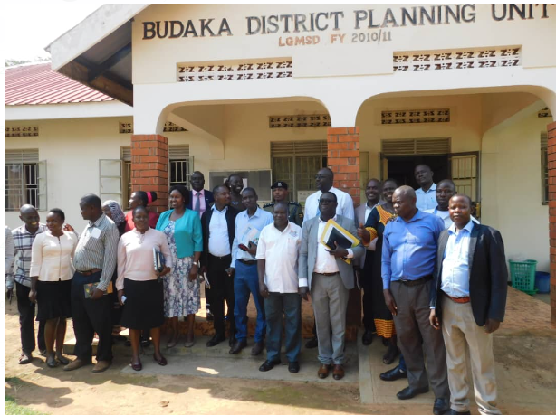

Figure :Stakeholders on dissemination of assessment results, 02 August 2023

**Performance Improvement Planning Template**

|  |  |  |  |  |
| --- | --- | --- | --- | --- |
| **Performance Concern as identified in the report** | **Expected Standard of Performance** | **Agreed Improvement Action** | **Time Frame** | **Responsible Person** |
|  |  |  |  |  |
|  |  |  |  |  |
|  |  |  |  |  |